**Multi Step Enrolment flow:**

1)Create packet with demographics details 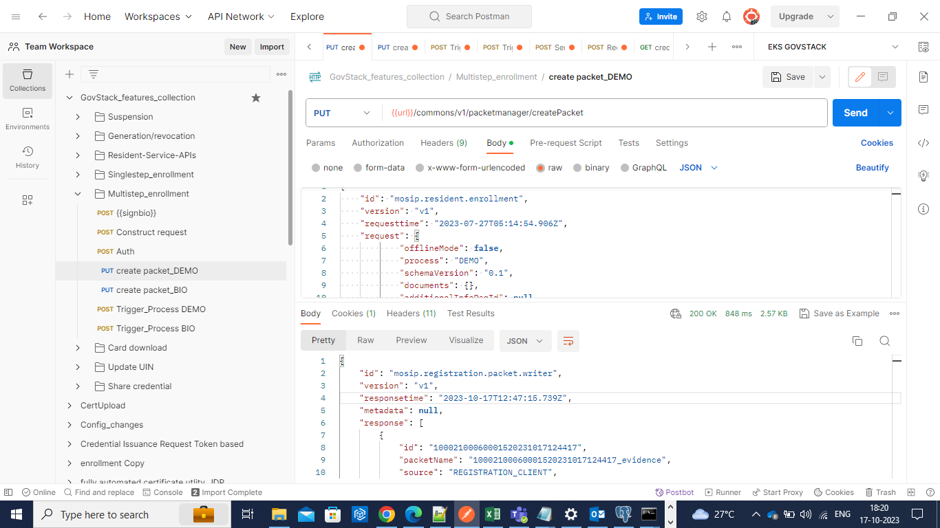

2) Create packet with biometric details.

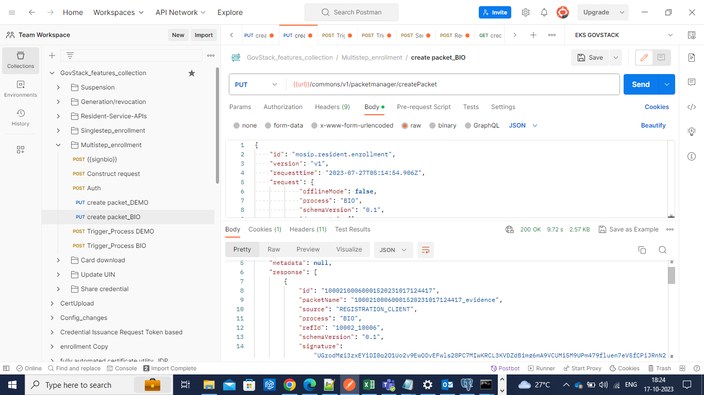

3)Upload demographic packet.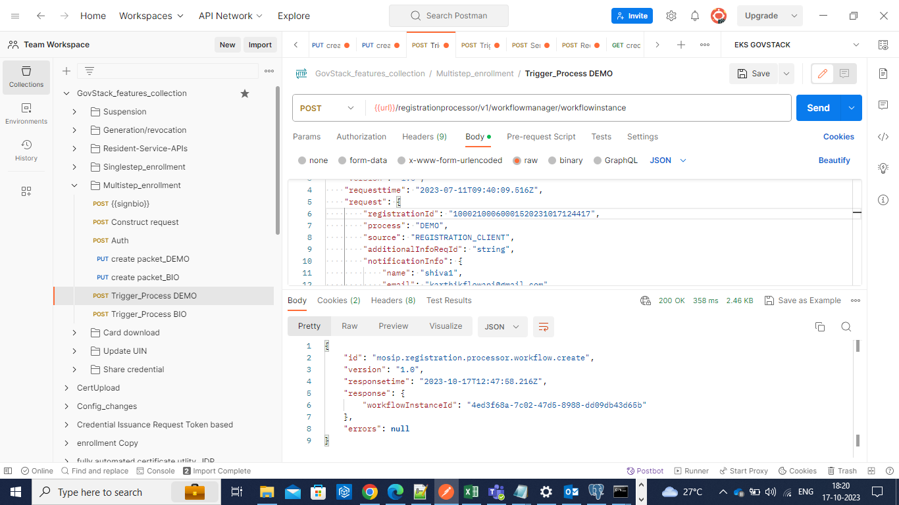

4) Upload biometric packet. 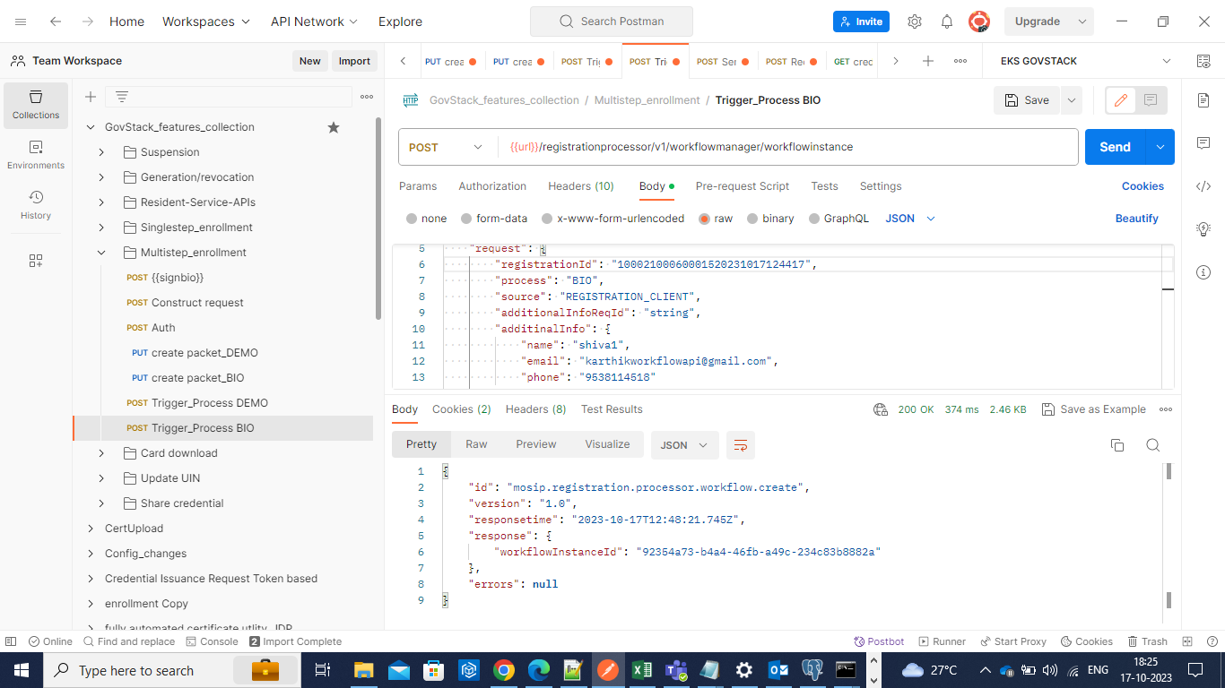

5)Notification for registration confirmation and requesting the additional details for progressing on the application of UIN

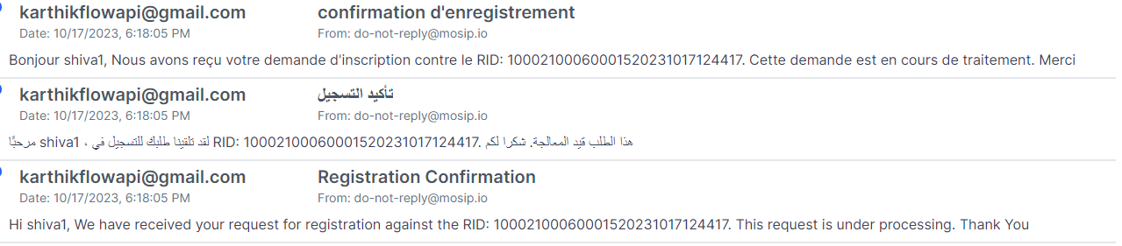

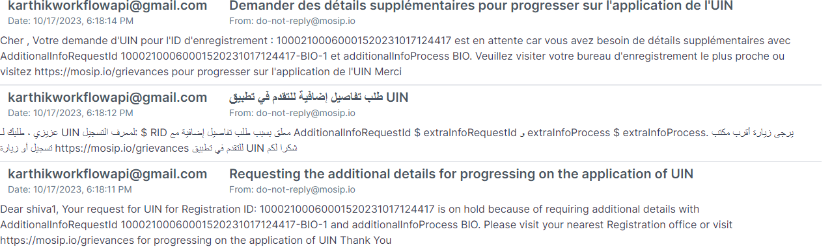

6)Notification for UIN generation.

